Normal text

# Heading1

## Heading2

### Heading3

#### Heading4

|  |
| --- |
| **URL:** <http://spaceotechnologies.com/web-development-consulting-services>  **Meta Title:** Web Development Consulting Services - Space-O Technologies  **Meta Description:** Space-O offers comprehensive web development consulting services, spanning strategy to execution, aligning your web roadmap with performance, growth, and security. |

[HERO]

# Web Development Consulting Services

Struggling with slow website performance, unclear tech decisions, or platforms that don’t scale with your business? Our web development consulting services are designed to eliminate guesswork and align your digital presence with tangible business outcomes. Whether you’re launching a new product, modernizing an outdated platform, or scaling your online operations, we provide expert guidance on architecture, technology stack, user experience, and performance optimization. **The result?**

* **High-performing websites** that load faster and deliver smoother user experiences
* **Scalable, future-ready architecture** designed to support business growth
* **Technology stack recommendations** that reduce risk and speed up development
* **Reduced development risks** through expert audits, feasibility checks, and strategic planning





[SERVICES_GRID]

## Web Devel opment Consulting Services to Build the Right Foundation

We help businesses make smart, strategic decisions before development begins, defining the right tech stack, architecture, and roadmap to build scalable, responsive, and high-performing web solutions tailored to business goals.

### Technology & Architecture Consulting

A web development consultant helps select the right web technologies and architecture to ensure faster development, easier maintenance, and long-term alignment with your business goals.

* Evaluate the existing tech to identify gaps, risks, and opportunities
* Recommend a future-proof tech stack that fits your business roadmap
* Design a modular, scalable architecture to reduce rework
* Define integration strategies for third-party systems

### UI/UX & Performance Optimization

We enhance usability and speed through expert development consulting, delivering mobile-friendly and user-friendly experiences that increase engagement and boost conversion rates.

* Audit user journeys to uncover friction and drop-off points
* Recommend UI improvements to support clearer calls-to-action & navigation
* Optimize page load speed to meet Core Web Vitals and SEO standards
* Balance aesthetics and usability to improve retention & drive more conversions

### Modernization & Legacy System Assessment

Modernize outdated websites with support from experienced web consultants. We improve performance, update technologies, and align your platform with current business and user needs.

* Rebuild or refactor outdated web development frameworks
* Enhance site usability and mobile compatibility
* Migrate legacy systems to modern web technologies
* Deliver cost-effective, scalable [web development services](https://www.spaceotechnologies.com/services/web-development/)

### Code Audits & Quality Assurance

Our web development consulting services include in-depth code audits that ensure your software is secure, efficient, maintainable, and ready to scale with minimal technical risk and long-term cost.

* Detect and fix code-level performance issues
* Enhance quality, maintainability, and scalability
* Apply secure coding best practices to enhance your website
* Recommend improvements for high-performing web solutions

### Product Strategy & MVP Scoping

Web consultants guide early-stage planning by identifying must-have MVP features, selecting the right technologies, and creating a scalable roadmap tailored to your product vision and business priorities.

* Fast-track launch with strategic feature prioritization
* Eliminate guesswork through comprehensive market validation
* Scale strategically with growth-focused development roadmaps
* Control costs with transparent budgeting optimization

### Third-Party Integration Consulting

We integrate CRM systems, payment gateways, and analytics tools to extend your website’s functionality and support seamless digital marketing and sales operations.

* Map secure API integrations into your website
* Enable real-time data flow between platforms
* Optimize CRM and ERP connections
* Improve customer journey through automation

[SERVICES_ACCORDION]

### Security & Compliance Advisory

Protect your users, site data, and brand reputation with development consulting focused on security, privacy, and compliance with industry regulations.

* Audit for software and web security vulnerabilities
* Recommend compliance practices (GDPR, PCI, etc.)
* Secure user data across business processes
* Apply standards for eCommerce and enterprise sites

### Cloud & Infrastructure Planning

Plan your cloud infrastructure to ensure your web solutions are reliable, fast, and ready to support growth, without overspending on unnecessary resources.

* Recommend cost-effective cloud strategies
* Design scalable, optimized hosting environments
* Support CI/CD and DevOps workflows
* Plan for traffic spikes and disaster recovery

[CTA_SIMPLE]

|  |
| --- |
| **Need Expert Guidance Before Making Expensive Technology Investment Decisions?**  Avoid costly mistakes with consultation from experienced web development professionals. Make informed decisions that protect your investment and drive growth.  **Book Free Consulting Session** |

[PORTFOLIO]

## Proven Results: Real Projects That Drive Business Growth

See how we've transformed complex business challenges into measurable success stories across diverse industries, using tailored web solutions, innovative thinking, and proven development strategies.

### Secure CCTV Registry Platform for Enhanced Community Safety

We developed a secure web platform that enables citizens to register their private CCTV systems for law enforcement collaboration. Built with PHP Laravel and PostgreSQL, the solution features encrypted data handling, intuitive registration workflows, and seamless integration with investigative tools. Our architecture ensures optimal performance, strict data privacy, and enhanced cooperation between communities and law enforcement for effective crime prevention initiatives.

**[Check the Project Details](https://www.spaceotechnologies.com/project/cctv-data-management-platform/)**

### Field Service Management System for Logistics Operations

We developed CrewVision, a comprehensive web-based logistics platform using Laravel PHP and MySQL with interactive JavaScript interfaces. The system delivers real-time task allocation, automated field updates, and operational analytics through a robust application architecture. Engineered for scalability and precision, this solution eliminates scheduling conflicts, enhances workforce coordination, and significantly improves service efficiency across logistics operations.

**[Check the Project Details](https://www.spaceotechnologies.com/project/field-service-management-solution/)**

### An eCommerce Marketplace for Waste Management Equipment

We engineered Parts Express, a scalable marketplace utilizing Laravel PHP 8.1 for the nationwide buying and selling of waste management equipment. Built with MySQL data integrity and AWS cloud deployment, the platform features advanced product filtering, secure Stripe payments, real-time inventory management, and comprehensive seller dashboards. Our modular PHP architecture ensures optimal performance, long-term maintainability, and seamless scalability for the future.

**[Check the Project Details](https://www.spaceotechnologies.com/project/parts-express-ecommerce-marketplace-development/)**



[TESTIMONIAL]

## What Our Clients Say About Working With Us

We were drowning in manual processes, and our old system was crashing weekly. I was honestly skeptical about hiring another development team after getting burned twice before. However, from the first meeting, these web development consultancy stood out. They spent hours understanding our business before talking about any technology. Instead of promising everything, they provided us with a realistic 4-month timeline and adhered to it. The results speak for themselves: our order processing time dropped from **45 minutes to 8 minutes**, we eliminated **23 hours of weekly manual data entry**, and our customer satisfaction scores jumped from **3.2 to 4.7 out of 5.**

**These guys actually listen and deliver what they promise!**

**S. Mitchell**

**CEO at Logistics Business**

[View All Testimonials](https://www.spaceotechnologies.com/company/client-testimonials/)

## 

[BENEFITS]

## Why Space-O Technologies is Your Strategic Partner for Web Development Consulting Services

From crashing servers to abandoned carts, we help CTOs navigate the technical challenges that stall growth. Our web consulting services bring clarity to complex architecture decisions, reduce technical debt, and build a solid foundation for what’s next.

### Strategic Technology Roadmapping

Our consulting services include long-term technology planning aligned with business growth objectives. We create detailed roadmaps for web platform evolution, feature prioritization, and resource allocation optimization.

### Data-Driven Architecture Decisions

No guesswork here at Space-O Technologies. We analyze your traffic patterns, growth projections, and integration needs to recommend technologies that align with your roadmap, not just the trending frameworks everyone's talking about.

### Cost-Effective Consulting Models

We offer flexible engagement options including project-based, retainer, and hybrid consulting models. Space-O Technologies consistently delivers web development consulting at 30-40% lower costs than traditional enterprise consulting firms.

### Certified Technology Partnerships

Space-O Technologies maintains official partnerships with AWS, Google Cloud, and Microsoft Azure. Our certified consultants leverage these relationships to provide enterprise-grade web development solutions with preferential support.

### 24/7 Critical Support Coverage

Our web development consultants provide round-the-clock emergency support for critical system issues. We maintain a dedicated team of on-call consultants to promptly address performance degradation, security incidents, and infrastructure failures.

### Industry-Specific Solutions

From e-commerce conversion optimization to SaaS performance scaling, we understand sector-specific challenges. Your healthcare compliance needs or fintech security requirements aren't foreign concepts to us—they're our expertise.

[CONTENT_FORM]

## Web Development Consulting to Future-Proof Your Digital Presence

Web development consultation gives you expert guidance and strategic advice to build a website that’s not just functional, but built to scale. Whether you're launching or enhancing an existing platform, web development consultants help align your site with your business goals, user needs, and modern technological standards. Web development consulting encompasses everything from planning and technology selection to optimization and support, ensuring your growth remains on track.

**What Web Consulting Can Help You With:**

* **Strategic Planning & Roadmapping:** Define goals, audience, and execution plan.
* **Technology & Architecture Consulting:** Select the optimal stack and structure for scalability.
* **UX/UI Design Audits:** Enhance usability and visual impact.
* **Performance, SEO & Security:** Ensure speed, visibility, and safety.
* **Post-Launch Support & Training:** Maintain, improve, and empower your team.

[BENEFITS]

## Key Benefits of Web Development Consulting Services

Partnering with a web development consulting company offers more than just technical guidance; it delivers strategic insights, tailored solutions, and expert recommendations to elevate your digital presence.

### Eliminate Performance Issues

Transform slow-loading websites that drive customers away into fast, responsive platforms. Professional consulting identifies the exact causes of performance issues and implements solutions that significantly reduce bounce rates.

### Boost Conversion Rates

Convert more visitors into paying customers through strategic user experience optimization. Web development consultants address checkout friction, navigation problems, and trust signals that directly impact your revenue generation.

### Clean Up Technical Debt

Replace messy, hard-to-maintain code with clean, efficient systems. Web development consulting reduces ongoing development costs and makes future updates faster and more affordable for your team.

### Accelerate Development Timelines

Complete projects faster with fewer revisions and budget overruns. Web consulting services streamline development processes, preventing common mistakes that cause delays and unnecessary cost increases.

### Maximize Development ROI

Maximize the value of every development dollar spent through strategic resource allocation. Expert consulting prevents wasteful spending on unnecessary features while prioritizing improvements that deliver measurable business impact.

### Execute Risk-Free Redesigns

Launch major website overhauls without business disruption. Expert web development consulting services provide detailed planning, testing protocols, and migration strategies that protect your existing traffic and search rankings.

[CTA SIMPLE]

|  |
| --- |
| **Tired of Websites that Don't Convert Visitors into Paying Customers?**  Your website should be your best salesperson, working 24/7 to grow your business. Discover how strategic web development can boost your conversion rates.  **[Get Strategy Audit](https://www.spaceotechnologies.com/contact-us/)** |

[PROCESS]

## Our Proven Process for Web Development Consulting Services

With hundreds of successful projects under our belt, our refined 6-step process eliminates uncertainty and delivers consistent, high-quality results. Each phase includes clear deliverables, fixed timelines, and key client touchpoints.

### Discovery & Requirements Analysis

Our web development consultants start by understanding your goals, challenges, and technical specifications. Through stakeholder sessions and system audits, we define precise requirements that guide every decision throughout the project lifecycle.

### Architecture Design and Planning

Our expert architects at Space-O Technologies translate your needs into scalable technical blueprints, complete with system design, data flows, and wireframes, ensuring a future-proof foundation that aligns with your business and tech stack.

### Environment Setup & Foundation

We set up secure, cloud-ready environments with automated deployment pipelines, backups, and monitoring. This ensures your web development starts on a strong, stable, and production-ready technical base.

### Iterative Development & Testing

Our Agile sprints deliver usable features every cycle. You'll gain access to staging environments, weekly demos, and regular feedback loops, keeping you in control and ensuring alignment from the project's inception.

### User Acceptance & Team Training

We guide your team through hands-on testing, real-world scenario walkthroughs, and tailored system training. This ensures everyone is fully prepared to operate, manage, and support the platform post-launch.

### Deployment & Post-Launch Optimization

With zero-downtime deployment and real-time monitoring, we ensure a seamless go-live. Following launch, we offer performance tuning, immediate support, and long-term optimization strategies.

[TECHNOLOGY]

## Scalable, Secure Web Tech Stack We Use for Web Development

We use modern, battle-tested technologies to build high-performing, flexible, and secure web platforms, designed to evolve with your business and deliver long-term value.

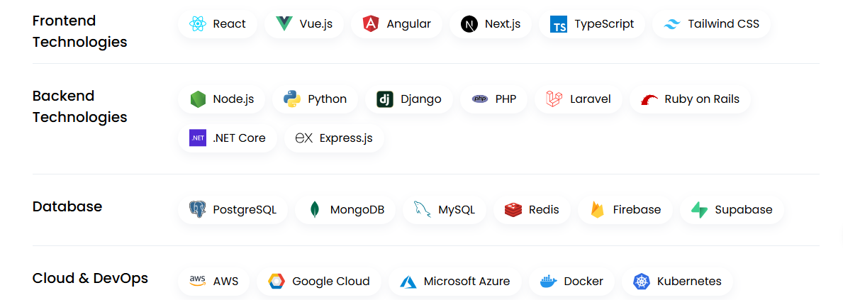

[INDUSTRIES]

## Industries We Serve

As a web development consulting agency, we cater to a diverse range of industries, delivering custom-built solutions that address domain-specific challenges and drive business outcomes.

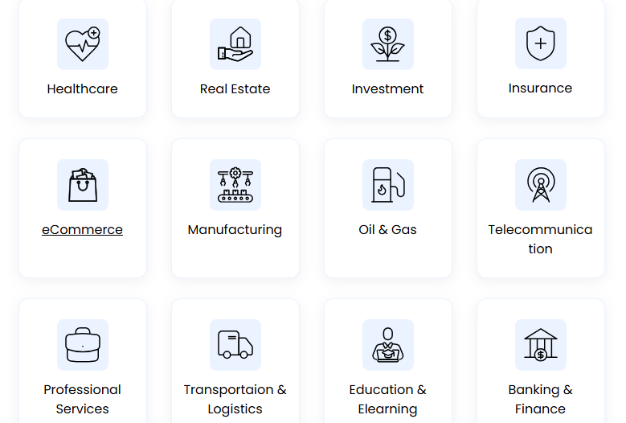

[FAQ]

## FAQs About Web Development Consulting

### What is web development consulting?

Web development consulting is a strategic service that combines technical expertise with business insight to help organizations build, optimize, or modernize their web-based systems and applications.

Unlike traditional development agencies that simply build what you ask for, web development consultants analyze your business needs, existing technology stack, and growth objectives to recommend the most effective solutions. We work as your technical advisors, helping you make informed decisions about technology investments, architecture choices, and implementation strategies.

**Key areas include:** System architecture design, technology stack selection, performance optimization, security auditing, integration planning, and long-term scalability strategies.

### How long does a typical web development consulting project take?

Project timelines vary significantly based on scope and complexity, but here are typical ranges:

* Small projects (MVP, simple integrations): 4-8 weeks
* Medium projects (custom applications, API development): 3-6 months
* Large projects (enterprise systems, complex integrations): 6-12 months

During our initial discovery phase, we provide detailed timelines with specific milestones. We use agile methodology, so you'll see working features every 1-2 weeks rather than waiting until the end.

### Do you work with existing development teams or replace them?

We work both ways, depending on your needs and preferences.

**Collaborative approach:** We often work alongside your existing team, providing strategic guidance, code reviews, architecture planning, and mentoring. This is ideal when you have capable developers but need senior-level expertise for complex decisions.

**Full delivery:** We can also handle complete project delivery when you need dedicated resources or specialized skills your team doesn't have.

### What kind of support do you provide after the project launches?

Post-launch support is crucial for long-term success. We offer several support options:

* **Strategic consultation:** Quarterly reviews to discuss new features, technology updates, and scaling strategies as your business grows.
* **Immediate post-launch (included):** 48-hour monitoring, immediate bug fixes, and performance optimization for the first week after deployment.
* **Ongoing maintenance:** Regular updates, security patches, performance monitoring, and technical support on retainer or project basis.

We also provide comprehensive documentation and training, allowing your team to handle day-to-day management independently if preferred.

### How do you determine the price of your web development consulting services?

We offer flexible pricing models to match different project types and client preferences:

* **Fixed-price projects:** Best for well-defined scopes with clear deliverables. You know the total cost upfront.
* **Time and materials:** Ideal for ongoing consulting or projects with evolving requirements. You pay for actual time invested.
* **Retainer agreements:** Monthly arrangements for ongoing support, maintenance, or strategic consultation.

After our initial consultation, we'll recommend the pricing model that best fits your project and provide a detailed proposal with transparent cost breakdowns.

### Can you help modernize our existing legacy system?

Absolutely. Legacy system modernization is one of our specialties, and we understand the unique challenges that come with it.

**Our approach:** Our website development consultant starts with a comprehensive audit of your existing system, then creates a phased modernization plan that minimizes business disruption while delivering immediate value.

**Common strategies:** API-first architecture to gradually replace components, data migration planning, integration bridges during transition periods, and staff training on new systems.

We've successfully modernized systems for businesses that couldn't afford downtime, ensuring continuity while dramatically improving performance, security, and maintainability.

### Will my website/system work on phones and tablets?

Yes, absolutely. In 2025, if your website doesn't work perfectly on mobile devices, you're losing customers every day. Everything we build is "mobile-first," meaning we design for phones and tablets first, then ensure it looks great on computers as well. Your customers should have the same great experience whether they're on their phone at lunch or on their laptop at home.